Meeting Scheduler

**Software Requirements Specification**

Version 1.1



**Group Id: S22024B990**

**Supervisor Name: Dr. Sarfraz Ahmad Awan**

**Revision History**

|  |  |  |  |
| --- | --- | --- | --- |
| **Date (dd/mm/yyyy)** | **Version** | **Description** | **Author** |
| 03/08/2022 | 1.0 | This meeting scheduler web application will address the challenges of manual meeting process. The goal of this application is to develop an automated meeting scheduler which could coordinate among the members digitally.  This is a web-based application.  SRS document includes scope of the project, Functional & non-Functional requirements, use case Diagram, Usage Scenarios, Adopted methodology, and Work Plan of the project. | BC190200421 |
|  |  |  |  |
|  |  |  |  |
|  |  |  |  |

**Table of Contents**

1. Scope (of the project)
2. Functional Requirements Non-Functional requirements
3. Use Case Diagram
4. Usage Scenarios
5. Adopted Methodology
6. Work Plan (Use MS Project to create Schedule/Work Plan)

**SRS Document**

Scope of Project:

Meeting Scheduler can do lot of things like contact the participants, ask them about their availability preferences, and inquire about their possible dates of availability. After these steps one could reach to possible date that could be acceptable for all participants. Host can start the meeting at the scheduled date and time and asks the participants to join the meeting.

This application is being presented to address the challenges of manual meeting process. The goal of this application is to develop an automated meeting scheduler which could coordinate among the members digitally.

This is a web-based application.

Product Characteristics/ Requirements:

1. Templates and tools:

The scheduler will allow authorized users to use the application. First Sign-up to use the application.

1. Sign-up:

Provide all necessary details required to create an account. On successful sign-up, you will receive a confirmation email and maybe you also receive a SMS.

1. Sign-In:

Provide your email address and password to sign-in to the application.

1. New Meeting:

Click on ‘New Meeting’ button to schedule a meeting. Add all the details of meeting and invite the participants to the meeting.

Participants must be authorized users of application.

1. Invitations:

A user will receive meeting invitations in invitations.

User have to select the possible dates from available dates of a meeting.

1. Proposed Meetings:

All pending meetings will be show there. The host can see the selected dates of participants for meeting and host can select a final date to confirm/ fix the meeting.

1. Confirmed Meetings:

The host can update confirmed meetings.

An email of confirmed meeting will be sent to all the participants. The host will receive feedbacks from participants whether they are attending the meeting or not.

Project Deliverables:

The project is divided into four phases (SRS document, Design Document, Prototype Phase, and Final deliverable) with each having multiple deliverables in each phase and their corresponding deadlines and start dates.

Constraints:

* User should be able to access the application over the network.
* Participants must be authorized users of application.
* Host can schedule, update, or start a meeting.

Assumptions:

* This being a web-based application, can be accessed 24/7.
* Network connection should be available to use the application.
* System requires user be familiar with basic windows and web browser operations.
* System assumes that all participants will be actively involved in responding to meeting requests and honor the commitments.

Functional and non-Functional Requirements:

Functional Requirements:

* Sign-up:
* Any user can sign-up.

Possible information attributes for sign-up process could be

* User name
* Email Address
* Password
* Time Zone
* Earlies time
* Latest Time
* Created at
* Updated at
* Etc.
* On Successful Registration, an email should be dispatched to user on his/her email address.

SMS confirmation will be an additional feature.

* ‘How it works’ Tab:
* On Home Page of application, there will be ‘How it works’ tab available. It will be guiding the use of different features of application to the users.
* ‘Forgot Password?’:
* Authorized user may reset his account password through ‘forgot password?’ link.
* Sign-In:
* There will be an interface for users to sign-in the application. It means only authorized users will be able to use the application.
* Settings:
* User will be able to change his profile settings. He may change his basic info, contact info, recovery phone no., or change password.
* User may change his general settings of audio (microphone) or video (camera).
* Meeting Schedule
* Any user can initiate the meeting schedule process. By default, initiator is host of meeting.

Meeting may have various information attributes. Some of those may be,

* Title
* Description
* Start time
* Duration
* Status (Proposed, Confirmed)
* Password
* Created at
* Updated at
* Etc.
* Host has provision to invite participants. There may be different meeting statuses like proposed or confirmed.
* Host may propose different meeting dates with times and participants will be able to choose possible dates as per its availability preference.
* Host will finalize the date and fix the meeting at a particular date.
* Once it’s fixed, then every participant will give his/her feedback whether he/she attending the meeting or not.
* Host may upload meeting agenda with meeting for meeting members.
* At end of meeting, host may associate minutes of meeting.
* Host can start the meeting through audio/ video conference at the scheduled date and time and participants will be able to join the meeting.
* During meeting, participants can ‘Hand Raise’ and host will be able to see this.
* Sign-out:
* User can sign out of application whenever he/ she wants to stop using application and its related services.

Non-Functional Requirements:

* Usability:
* Users must be able to easily schedule a meeting.
* Security:
* Users must be able to access the application after successful authentication.
* Interface of user should be password protected.
* Only participants can join the particular meeting.
* Flexibility:
* Meeting date and time should be convenient for participants.
* Convenience:
* The app shall be convenient to use in terms of accessing and using interface.
* Accuracy:
* The application shall be accurate in terms of scheduling.
* Scalability:
* The application shall be built in such a way that new functionalities can be added easily in future as per features required.
* Performance:
* Authorization should be completed within 1 minute 90% of time.
* Average authorization confirmation should not exceed 30 seconds.
* Portability:
* The system should run on Windows 7 and above as well as Windows 10 and above.

Use Case Diagram(s):

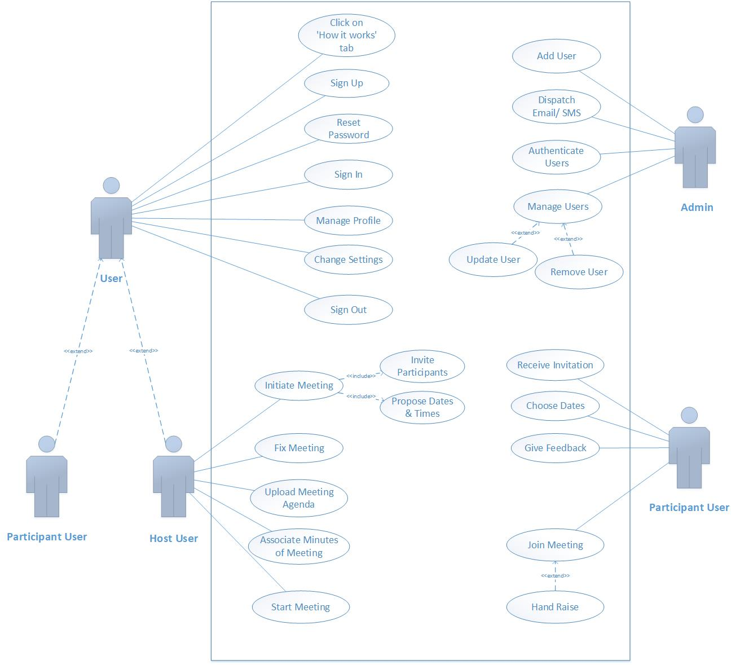

Usage Scenarios:

|  |  |
| --- | --- |
| **Use Case Title** | Click on ‘How it works’ tab |
| **Use Case ID** | UC01 |
| **Actors** | User |
| **Description** | User will click on ‘How it works’ tab to seek guidance for the use of application and its different features. |
| **Pre-Conditions:** | User must be on home page of application. |
| **Actions** | * Search the desired web-based application in Google. * Open the application. * Click on ‘How it works’ tab. |
| **Post Conditions:** | User will be aware by the use of application and its features. |
| **Alternative Paths:** | Nil |
| **Exceptions** | Nil |
| **Author:** | BC190200421 |

|  |  |
| --- | --- |
| **Use Case Title** | Sign Up |
| **Use Case ID** | UC02 |
| **Actors** | User |
| **Description** | Any user can sign-up in order to sign-in to the application. A confirmation Email/ SMS will be dispatched to user. |
| **Pre-Conditions:** | User must have a valid email address. |
| **Actions** | * Search the desired web-based application in Google. * Fill the sign-up form with all necessary information. * Click on Sign up button. |
| **Post Conditions:** | A confirmation Email/ SMS will be received. |
| **Alternative Paths:** | If user doesn’t sign-up, he/ she will not be able to use the application. |
| **Exceptions** | The system will not allow a user to create an account, if he/ she have not a valid email address. |
| **Author:** | BC190200421 |

|  |  |
| --- | --- |
| **Use Case Title** | Add User |
| **Use Case ID** | UC03 |
| **Actors** | Admin |
| **Description** | Admin can add new users to the system after the sign-up process of application. |
| **Pre-Conditions:** | User must have completed the sign-up process. |
| **Actions** | * User performs **Sign Up** use case. * Admin adds the user to the system. |
| **Post Conditions:** | User is registered successfully. |
| **Alternative Paths:** | Nil |
| **Exceptions** | Admin will not add a new user to the system, if he/ she is already registered in the application with the same email address. |
| **Author:** | BC190200421 |

|  |  |
| --- | --- |
| **Use Case Title** | Dispatch Email/ SMS |
| **Use Case ID** | UC04 |
| **Actors** | Admin |
| **Description** | An email will be dispatched to the user on his/her email address on successful registration. SMS confirmation will be an additional feature. |
| **Pre-Conditions:** | User must be registered successfully. |
| **Actions** | * User performs **Sign Up** use case. * User will receive a confirmation Email/ SMS. |
| **Post Conditions:** | A confirmation Email/ SMS will be received. |
| **Alternative Paths:** | If user doesn’t receive confirmation Email/ SMS, he/ she should try to register again to the application. |
| **Exceptions** | The system will not dispatch an email/ SMS to the user, if he/ she have provided any incorrect information. |
| **Author:** | BC190200421 |

|  |  |
| --- | --- |
| **Use Case Title** | Reset Password |
| **Use Case ID** | UC05 |
| **Actors** | User |
| **Description** | If any authorized user doesn’t remember his account password, he/ she will be able to reset his account password. |
| **Pre-Conditions:** | User must be authorized. |
| **Actions** | * Search the desired web-based application in Google. * Open sign in form of application. * Click on ‘forgot password’ link. * Enter your email address. |
| **Post Conditions:** | User will receive an email containing the link to reset his account password. |
| **Alternative Paths:** | Try to remember your password. |
| **Exceptions** | The system will not allow a user to reset password, if he/ she is not already registered in the system. |
| **Author:** | BC190200421 |

|  |  |
| --- | --- |
| **Use Case Title** | Sign In |
| **Use Case ID** | UC06 |
| **Actors** | User |
| **Description** | There will be an interface for users to sign-in to use the application. |
| **Pre-Conditions:** | User must be authorized. |
| **Actions** | * Enter email and password. * Click on Sign In button. |
| **Post Conditions:** | Signed-In Successfully and appealing interface is available to use. |
| **Alternative Paths:** | If user can’t sign-in to the application, click on forgot password link. |
| **Exceptions** | The system will not allow user to sign-in, if he/ she have entered wrong email/ password. |
| **Author:** | BC190200421 |

|  |  |
| --- | --- |
| **Use Case Title** | Authenticate Users |
| **Use Case ID** | UC07 |
| **Actors** | Admin |
| **Description** | To use the features of application, user must be authorized. Whenever user will try to sign-in to the application, admin will authenticate the user by checking the database of application then allow the user to enter. |
| **Pre-Conditions:** | User data must be available in the system. |
| **Actions** | * User try to sign in to the application. * Admin match the user from database. * Allow/ Reject to sign in. |
| **Post Conditions:** | User have been signed in to the application. |
| **Alternative Paths:** | Nil |
| **Exceptions** | The system will not authenticate a user, if he is already not registered to the application. |
| **Author:** | BC190200421 |

|  |  |
| --- | --- |
| **Use Case Title** | Initiate Meeting |
| **Use Case ID** | UC08 |
| **Actors** | Host User |
| **Description** | Any user can initiate the meeting schedule process. Initiator is the host of meeting. Host have authority of all meeting schedule process. |
| **Pre-Conditions:** | User must be authorized. |
| **Actions** | * Sign-in to the application. * Click on ‘New Meeting’. * Add all details of meeting. * Propose Dates & Times for meeting. * Click on Invite Participants button to invite. * Click on *Save* button. |
| **Post Conditions:** | The meeting invitation will be sent to all user participants. |
| **Includes:** | Propose Dates & Times, Invite Participants |
| **Alternative Paths:** | Initiate a new meeting again. |
| **Exceptions** | Provide all necessary details for meeting. |
| **Author:** | BC190200421 |

|  |  |
| --- | --- |
| **Use Case Title** | Propose Dates & Times |
| **Use Case ID** | UC09 |
| **Actors** | Host User |
| **Description** | Host will propose different dates and times for the meeting. |
| **Pre-Conditions:** | User must initiate a new meeting. |
| **Actions** | * User performs **Initiate Meeting** use case. * Propose different dates and times for the meeting. * Click on *Save* button. |
| **Post Conditions:** | User participant will be able to choose dates of meeting. |
| **Alternative Paths:** | Nil |
| **Exceptions** | User host can propose five different dates. |
| **Author:** | BC190200421 |

|  |  |
| --- | --- |
| **Use Case Title** | Invite Participants |
| **Use Case ID** | UC10 |
| **Actors** | Host User |
| **Description** | Host will invite participants for the new initiated meeting. |
| **Pre-Conditions:** | User must have initiated a meeting. |
| **Actions** | * User performs **Initiate Meeting** use case. * User performs *Propose Dates & Times* use case. * Click on Invite Participants button. |
| **Post Conditions:** | An invitation will be sent to all the participants. |
| **Alternative Paths:** | Initiate a new meeting. |
| **Exceptions** | Participants must be authorized users of application. |
| **Author:** | BC190200421 |

|  |  |
| --- | --- |
| **Use Case Title** | Receive Invitation |
| **Use Case ID** | UC11 |
| **Actors** | Participant User |
| **Description** | Participant user will receive the meeting invitation sent by the host of meeting. |
| **Pre-Conditions:** | Participant must be authorized user of application. |
| **Actions** | * Sign-in to the application. * Click on Invitations. * Check the meeting invitation you have received. |
| **Post Conditions:** | You have a meeting invitation. |
| **Alternative Paths:** | Reload the browser and try again. |
| **Exceptions** | The system will not allow a user to receive invitation without sign-in to the application. |
| **Author:** | BC190200421 |

|  |  |
| --- | --- |
| **Use Case Title** | Choose Dates |
| **Use Case ID** | UC12 |
| **Actors** | Participant User |
| **Description** | Participant User will receive meeting invitation by the host. He/ She have to choose the possible dates from the dates and times proposed by the host. |
| **Pre-Conditions:** | Participant User should have an invitation. |
| **Actions** | * Click on Invitations. * Check the meeting invitation and choose possible dates. * Click on *Confirm* button. |
| **Post Conditions:** | Host user can see the dates selected by the participant. |
| **Alternative Paths:** | Nil |
| **Exceptions** | Participant user can only choose dates from dates proposed by the host. |
| **Author:** | BC190200421 |

|  |  |
| --- | --- |
| **Use Case Title** | Fix Meeting |
| **Use Case ID** | UC13 |
| **Actors** | Host User |
| **Description** | Host user will finalize a date for the meeting from the dates already proposed by him after seeing which dates have been chosen by the participants. Then host user will fix the meeting on a particular date. |
| **Pre-Conditions:** | Host user should receive the dates chosen by participants. |
| **Actions** | * Click on Proposed Meetings. * Open meeting you want to fix. * Select final date and final time. * Click on *Fix Meeting* button. |
| **Post Conditions:** | The specific meeting can be seen in confirmed meetings.  A notification/ email will be sent to all participants. |
| **Alternative Paths:** | Nil |
| **Exceptions** | Host user must select the final date from already proposed dates. |
| **Author:** | BC190200421 |

|  |  |
| --- | --- |
| **Use Case Title** | Give Feedback |
| **Use Case ID** | UC14 |
| **Actors** | Participant User |
| **Description** | Participant will give his/ her feedback for the confirmed meeting whether he/ she will attend the meeting or not. |
| **Pre-Conditions:** | Meeting must be confirmed. |
| **Actions** | * Click on Confirmed Meetings. * Click on *Feedback* button of particular meeting. * Write your feedback. * Click on *Send* button. |
| **Post Conditions:** | Host user will receive your feedback. |
| **Alternative Paths:** | Reload the browser and try again. |
| **Exceptions** | User must be a participant to give the feedback. |
| **Author:** | BC190200421 |

|  |  |
| --- | --- |
| **Use Case Title** | Upload Meeting Agenda |
| **Use Case ID** | UC15 |
| **Actors** | Host User |
| **Description** | User Host may upload the meeting agenda with meeting for meeting members. |
| **Pre-Conditions:** | The meeting must have initiated. |
| **Actions** | * Click on Confirmed Meetings. * Click on *Update* button of the particular meeting. * Enter the meeting agenda. * Click on *Save* button. |
| **Post Conditions:** | Meeting agenda will be uploaded with meeting. |
| **Alternative Paths:** | Reload the browser and try again. |
| **Exceptions** | Meeting should be confirmed. |
| **Author:** | BC190200421 |

|  |  |
| --- | --- |
| **Use Case Title** | Associate Minutes of Meeting |
| **Use Case ID** | UC16 |
| **Actors** | Host User |
| **Description** | At the end of meeting, host may associate the minutes of meeting. |
| **Pre-Conditions:** | Meeting must be completed before. |
| **Actions** | * Open *Confirmed Meetings*. * Click on *Update* button of particular meeting. * Enter minutes of meeting. * Click on *Save* button. |
| **Post Conditions:** | Minutes of meeting will be associated. |
| **Alternative Paths:** | Reload the browser and try again. |
| **Exceptions** | User Host can associate minutes. |
| **Author:** | BC190200421 |

|  |  |
| --- | --- |
| **Use Case Title** | Start Meeting |
| **Use Case ID** | UC17 |
| **Actors** | Host User |
| **Description** | Host can start the scheduled meeting through application. User participants will be able to join the meeting. |
| **Pre-Conditions:** | Meeting must be scheduled. |
| **Actions** | * Open *Confirmed Meetings*. * Click on *Start Meeting* button of particular meeting. |
| **Post Conditions:** | A video conference will start for the meeting. |
| **Alternative Paths:** | Nil |
| **Exceptions** | User participant cannot start the meeting. |
| **Author:** | BC190200421 |

|  |  |
| --- | --- |
| **Use Case Title** | Join Meeting |
| **Use Case ID** | UC18 |
| **Actors** | Participant User |
| **Description** | User participant can join the scheduled meeting started by the host. |
| **Pre-Conditions:** | User must be participant of meeting. |
| **Actions** | * Open *Confirmed Meetings*. * Click on *Join Meeting* button of particular meeting. |
| **Post Conditions:** | Participant have joined the video conference of meeting. |
| **Extend** | Hand Raise |
| **Alternative Paths:** | If you receive a notification or email to join, then accept to join meeting. |
| **Exceptions** | You are not participant of meeting. |
| **Author:** | BC190200421 |

|  |  |
| --- | --- |
| **Use Case Title** | Hand Raise |
| **Use Case ID** | UC19 |
| **Actors** | Participant User |
| **Description** | Participant User can hand raise during the meeting to show that he wants to say something and host will be able to see hand raise. |
| **Pre-Conditions:** | User must be participant of meeting. |
| **Actions** | * Open *Confirmed Meetings*. * Click on *Join Meeting* button of particular meeting. * Click on *Hand Raise* button. |
| **Post Conditions:** | Hand raise icon will be displayed to host and other participants. |
| **Alternative Paths:** | The user does not raise hand. |
| **Exceptions** | Nil |
| **Author:** | BC190200421 |

|  |  |
| --- | --- |
| **Use Case Title** | Change Settings |
| **Use Case ID** | UC20 |
| **Actors** | User |
| **Description** | User may change general settings of his account which includes audio (microphone) or video (camera). It will show whether microphone is on or not and camera is on or off. |
| **Pre-Conditions:** | User must be signed in to the application. |
| **Actions** | * Sign-in to the application. * Click on settings button. * Change the settings. * Click on *Save* button. |
| **Post Conditions:** | User will be able to use audio or video feature according to his desire. |
| **Alternative Paths:** | User can On/ Off his mic and camera during the meeting. |
| **Exceptions** | Nil |
| **Author:** | BC190200421 |

|  |  |
| --- | --- |
| **Use Case Title** | Manage Profile |
| **Use Case ID** | UC21 |
| **Actors** | User |
| **Description** | User will be able to change his profile settings. He may change his basic info, contact info, recovery phone no., or change password. |
| **Pre-Conditions:** | User must be signed in to the application. |
| **Actions** | * Sign-in to the application. * Click on ‘Manage Profile’ button. * Change the info. * Click on *Save* button. |
| **Post Conditions:** | User can be recognized by updated profile. |
| **Alternative Paths:** | The user does not save updates. |
| **Exceptions** | The system will not allow a user to again change his profile settings in a short span of time. |
| **Author:** | BC190200421 |

|  |  |
| --- | --- |
| **Use Case Title** | Manage Users |
| **Use Case ID** | UC22 |
| **Actors** | Admin |
| **Description** | Users will be managed by the admin. Admin can update users or delete users from the system. |
| **Pre-Conditions:** | User data must be available in the system. |
| **Actions** | * User performs *Manage Profile* use case. * Admin update/ remove user. |
| **Post Conditions:** | Data of user is updated in the system or user will not be found in case user is removed by the admin. |
| **Extends** | Update User, Remove User |
| **Alternative Paths:** | Nil |
| **Exceptions** | Nil |
| **Author:** | BC190200421 |

|  |  |
| --- | --- |
| **Use Case Title** | Update User |
| **Use Case ID** | UC23 |
| **Actors** | Admin |
| **Description** | Admin will update the user if he/ she wants to update his profile. |
| **Pre-Conditions:** | User data must be available in the system. |
| **Actions** | * Admin performs *Manage Users* use case. * Admin updates user profile. |
| **Post Conditions:** | Data of user is updated in the system and user can be recognized by updated profile. |
| **Alternative Paths:** | Nil |
| **Exceptions** | Nil |
| **Author:** | BC190200421 |

|  |  |
| --- | --- |
| **Use Case Title** | Remove User |
| **Use Case ID** | UC24 |
| **Actors** | Admin |
| **Description** | Admin can remove a user from the system, if user wants to delete his account or anyone complaint of that user. |
| **Pre-Conditions:** | User data must be available in the system. |
| **Actions** | * Admin deletes the data of user. |
| **Post Conditions:** | User can no longer found in the system. |
| **Alternative Paths:** | Nil |
| **Exceptions** | User not found. |
| **Author:** | BC190200421 |

|  |  |
| --- | --- |
| **Use Case Title** | Sign Out |
| **Use Case ID** | UC25 |
| **Actors** | User |
| **Description** | User can sign-out from the application anytime. |
| **Pre-Conditions:** | User must be already signed in. |
| **Actions** | * Click on ‘Sign out’ button. |
| **Post Conditions:** | User is signed out from application. |
| **Alternative Paths:** | Close the application. |
| **Exceptions** | Nil |
| **Author:** | BC190200421 |

Adopted Methodology

VU Process Model which is a combination of waterfall model and spiral model. The main reason for selecting this model is to get the benefits of both the spiral as well waterfall model. The main idea of this model is to avert risk as there is always an element of risk in development of software. We will be deploying the linear nature of waterfall model here along with minimizing risks through spiral model. In vu process model we will be working in phases to complete our given project.

Waterfall Model:

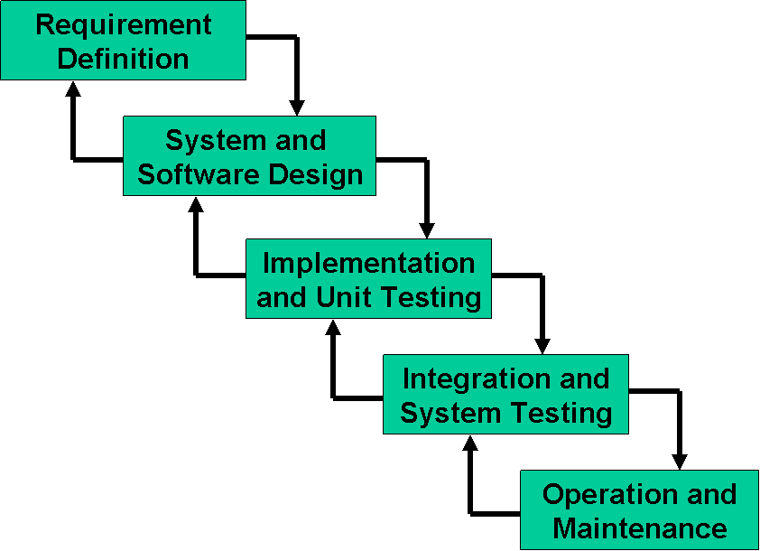 Waterfall model was the first published model of software process model. Waterfall model is also known as linear sequential model. It suggests a systematic, sequential approach to software development that begins at the system level and progresses through the analysis, design, coding, testing, and maintenance. The Waterfall Model is a documentation-driven model. It therefore generates complete and comprehensive documentation and hence makes the maintenance task much easier.

Advantages:

* Waterfall model is applicable for small project.
* It is simple and easy.
* Well understood milestones.
* Clearly defined stages.
* Process and results are well documented.
* Easy to manage due to the rigidity of the model.
* Each phase must be completed before the development of next phase.

Spiral Model:

The Spiral Model is Waterfall model plus risk analysis. In this case each stage is preceded by identification of alternatives and risk analysis and is then followed by evaluation and planning for the next phase. If risks cannot be resolved, project is immediately terminated. Because of the spiral nature of development, it is easy to judge how much to test and there is no distinction between development and maintenance. It however can only be used for large-scale software development and that too for internal (in-house) software only.

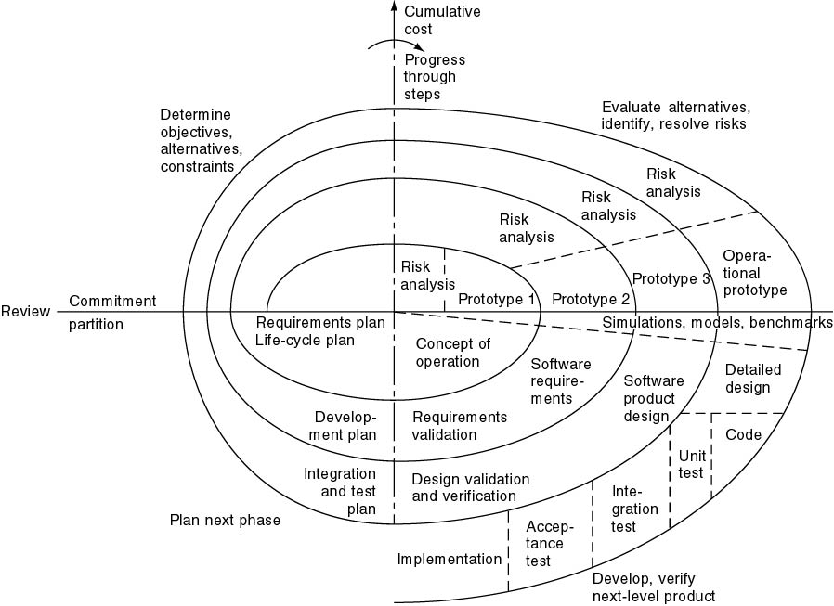

Advantages:

* Spiral model is used for large and complex projects.
* It is suitable for high-risk projects, where business needs may be unstable. A highly customized product can be developed using this.
* Errors or risks are identified and rectified earlier.
* Flexibility to change in spiral model is not difficult.
* Continuous or repeated development helps in risk management
* Additional functionality or changes can be done at a later stage.

Work Plan (Use MS Project to create Schedule/Work Plan)

